Tyler Niemonen Final Project Write-Up
Goal of Project:
From the beginning, I always wanted to create an OOB program that would allow a sports enthusiast like myself to be able to easily find sporting events in the local area. Living near Charlotte, NC there are plenty of opportunities to attend professional sporting events with teams such as the Carolina Panthers, Charlotte FC, and Charlotte Hornets. My goal was to make an easy to access program that would allow users, groups, companies to come to a one stop shop and be able to view the sporting events, buy tickets, and buy parking. This would allow them to have a more accessible and feasible manner to complete this process.
How does it Work?
Step 1: Download the included Java files and open them up with a program that you can read them. I personally used IntelliJ to work on this project and ensure that it ran properly. Some other programs you can use are Eclipse or Java IDE.
Step 2: Compile all the Java files and Run the MainFrame.java file.
Step 3: Once you have run the MainFrame.java file, the Home Page will appear.
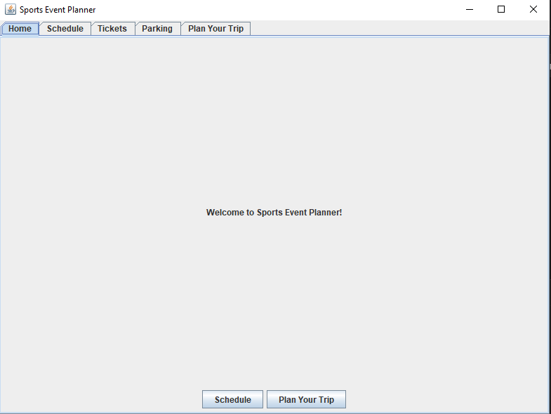
There are various tabs at the top that include, ‘Home’, ‘Schedule’, ‘Tickets’, ‘Parking’, and ‘Plan Your Trip’. You can click on the individual tabs, and they will show their specific information pertaining to that specific tab. Also, at the bottom there are more obvious buttons for ‘Schedule’ and ‘Plan Your Trip’. These can be leveraged as quick links if you are already using this program you are trying to attend one of these events.
Step 4: To use the main aspect of this program you will click the ‘Plan Your Trip’ tab at the top or simply click the ‘Plan Your Trip’ at the bottom of the page.
Step 5: Once in the ‘Plan Your Trip’ Tab, there are three selections that you will have to make: 1) the game or event you want to attend, 2) the type of ticket you want to purchase, and 3) parking type. Once that’s complete, you will click ‘Confirm Trip’ at the bottom.
'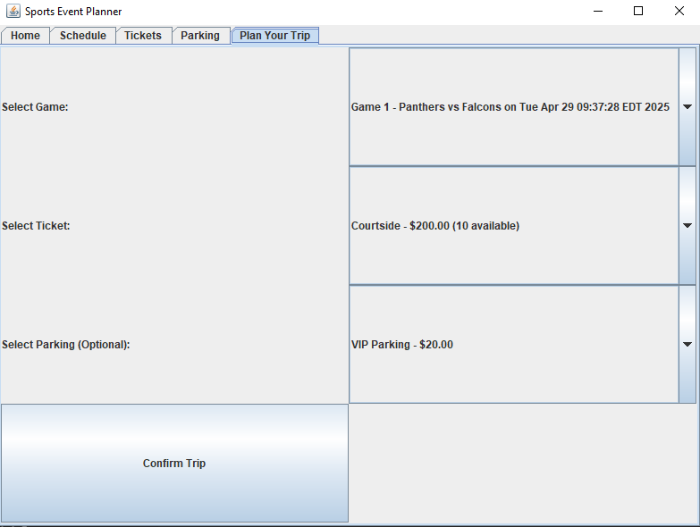
Step 6: After clicking ‘Confirm Trip’, this will bring you to the “Payment Page”. You are the prompted to fill in the proper information, as required. The way it needs to be entered is next to the specific field that you are filling out. If something is wrong/missing, it will let you know in the box on the bottom left to fix it. Once everything is entered correctly you hit ‘submit payment’. The options shown will then show the ‘total price’, a randomized ‘OrderID’, and that ‘Payment Successful’!
Step 7: You have finished the point of the program/project, and you can simply close the program or click the ‘Return to Home’ button to start from the beginning again.
Future Goals/Optimization:
I think for this project, like the professor mentioned, I wanted to keep it simple and straight to the point that essentially created a shell that still functioned. In the future, id would like to make the entire program more visually appealing and work on redesigning the pages. Also, having an option that would allow you to purchase multiple events, tickets, and parking at once would make the usability of the program more efficient for the end users.

